Ideation Phase
Define the Problem Statements

Date | 05 September 2026
Team ID
Project Name | Automated Network Request Management in ServiceNow
Maximum Marks | 2 Marks

Customer Problem Statement Template:
Create a problem statement to understand your customer's point of view. The Customer Problem Statement template helps you focus on what matters to create experiences people will love.
A well-articulated customer problem statement allows you and your team to find the ideal solution for the challenges your customers face. Throughout the process, you’ll also be able to empathize with your customers, which helps you better understand how they perceive your product or service.

Reference: https://miro.com/templates/customer-problem-statement/
Example:
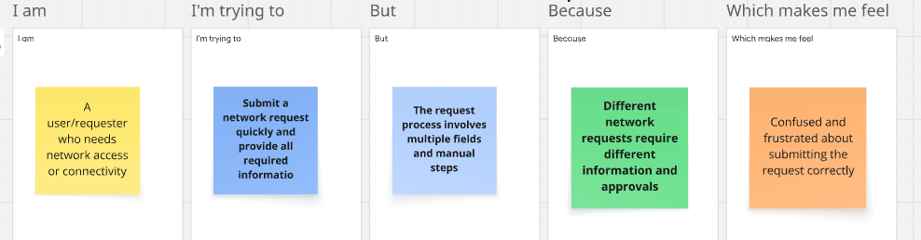

Problem Statement (PS) | I am (Customer) | I’m trying to | But | Because | Which makes me feel
PS-1 | A user/requester who needs network access or connectivity | Submit a network request quickly and provide all required information | Submit a network request quickly and provide all required information | Network requests can have different requirements depending on the request type, device, and network details | Confused and frustrated about submitting the request correctly
PS-2 | A manager or Network Team member responsible for reviewing and fulfilling network requests | Review, approve, and fulfill network requests efficiently
  Tracking approvals and creating fulfillment tasks can require manual coordination
  Request information, approval status, and fulfillment activities may be handled across different steps
  Delayed and concerned about missing or incorrectly processing requests

